The join( ) Method

The non-static join() method of class Thread lets one thread "join onto the end" of another thread. If you have a thread B that can't do its work until another thread A has completed its work, then you want thread B to "join" thread A. This means that thread B will not become runnable until A has finished (and entered the dead state).

Thread t = new Thread();
t.start();
t.join();

The preceding code takes the currently running thread (if this were in the main() method, then that would be the main thread) and joins it to the end of the thread referenced by t. This blocks the current thread from becoming runnable until after the thread referenced by t is no longer alive. In other words, the code t.join() means "Join me (the current thread) to the end of t, so that t must finish before I (the current thread) can run again." You can also call one of the overloaded versions of join() that takes a timeout duration, so that you're saying, "wait until thread t is done, but if it takes longer than 5,000 milliseconds, then stop waiting and become runnable anyway." Figure 9-3 shows the effect of the join() method.

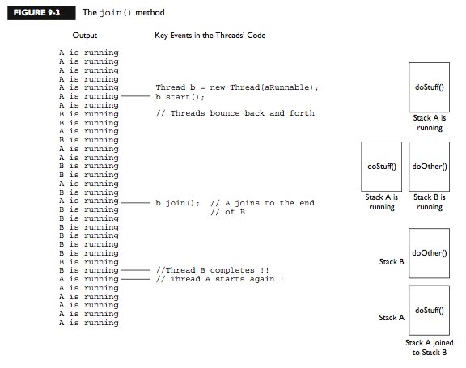

So far we've looked at three ways a running thread could leave the running state:

A call to sleep() Guaranteed to cause the current thread to stop executing for at least the specified sleep duration (although it might be interrupted before its specified time).

A call to yield() Not guaranteed to do much of anything, although typically it will cause the currently running thread to move back to runnable so that a thread of the same priority can have a chance.

A call to join() Guaranteed to cause the current thread to stop executing until the thread it joins with (in other words, the thread it calls join() on) completes, or if the thread it's trying to join with is not alive, however, the current thread won't need to back out.

